Decorating Rules

For all Tucson Rodeo Parade Museum Historic Wagon Rentals
- Do not move or remove any signage provided by the Parade Committee.
- The Parade theme this year is “Celebrating the 250th birthday of the United States of America”.
- Crepe paper flowers, streamers, and other colorful decorations are encouraged.
- Staples, nails, screws, etc. are not permitted on buggies, stagecoaches, or carriages because of the leather and finished wood sidings. These are historical, please respect them. Tape and zip ties are recommended.
- Float type construction is allowed on flatbeds, freighters, and farm wagons with a minimal use of nails and screws.
- Straw bales must be secured with tie down straps, rope, etc.
- Maximum height of 10 feet 6 inches for all entries. (Measure from ground to top of float)
- Banners, flags, or signs for non-commercial or non-profit entries are permitted.
- Under no circumstances are balloons or poppers allowed in the Parade and no decorations dragging from the wagon or touching the ground will be allowed.
- Throwing items from floats or horseback is not allowed and could result in your entry being pulled from the Parade Route.
- The Tucson Rodeo Parade Committee will not be responsible for any items that are left on the rental piece.
Thank you for your participation, and we look forward
to seeing you again in 2026 for our 101st anniversary!

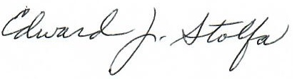
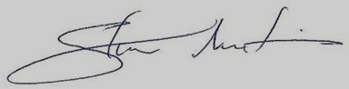
Sincerely,

Stan Martin Ed Stolfa
Executive Chairman Equipment Rentals
estolfa@msn.com

